**COIS-ADMN 3750 Fall 2021 Assignment 2 Report**

**Punyaja Mishra**

**0660001**

**Prepared for Sofie Andreou and Thomas Hughes**

**11 October 2021**

**Facebook :** [**https://www.facebook.com/6byGeeBeauty/**](https://www.facebook.com/6byGeeBeauty/)

**Instagram :** [**https://www.instagram.com/6bygeebeauty/**](https://www.instagram.com/6bygeebeauty/)

**Chosen Topic:**

Business – 6 By Gee Beauty

Chapter 11 - Facebook

**Question 1: Why do you think the business you have chosen is using this best practice online?**

The very main reason as to why the business chose Facebook (the best practice) online is to advertise their products on social media. The business I have chosen – 6 By Gee Beauty – is a business about beauty products of different famous and expensive brands such as clothes, candles, serums and the list is endless. The target audience for this business is multiple age groups. For instance there are products like Gold necklace with a price of almost $250, which is not exactly the first choice and very affordable by college/universities folks. While on the other hand, there are also apparels for less than $100 which would be something that the same college/university folks might be interested in. Therefore, it is important for the business to advertise accordingly.

Facebook is a more useful platform when target audience is greater than 40 years of age or at least 35 years of age. Therefore, all the women are able to find all their products and everything due to their Facebook Page. They also have an Instagram page for the ‘youngsters’ and thus claiming that age group of the target audience.

Facebook has many features that helps a business succeed. As we can see above, it allows the business to have their shop on the page and also keep FAQs (Frequently asked Questions) on their profile page. Since Facebook owns Instagram, there is an option to post the same post together at both the platforms with same caption, features and edit. This means, there is the option of also tagging the price of the product in a post over the product. The business can even put their local address if they have one, in this case, they do, and there is even the included google maps options for someone to check out how they can reach there if they wish to do so.

This is the reason I believe that the business chose to use Facebook (the best practice) in their favor.

**Question 2: How do you think this best practice has helped this business online?**

Of course, as I discussed above, Facebook offers many features on its user-friendly interface which is the reason the business decided to use it to promote their business. However, it is the duty and responsibility of the business with the business page on Facebook to use these features to their advantage. And I believe, that 6 By Gee Beauty did a good job.

They have both a Facebook and an Instagram page – they can post the same stuff at both place. It does not seem like something big but having the same advertisement both the places is important because there might be audience on the other platform interested in the product, but the business lost a customer because they believed that no one on the Facebook might be interested in it. Keeping consistency in the timeline is very important and 6 By Gee Beauty has done a good job in it. They have included good caption for every post they make. For instance,

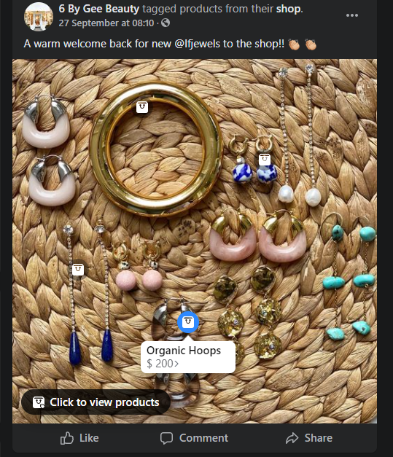

This is a simple post about jewelleries, however, the caption is not too intimidating with only information about the products and the new brand they got partnered up with it. Instead there is a communicative caption giving a hearty welcome to the new brand.

Similarly, as we saw in the snap in the previous question, they have included some FAQs that are useful so that people don’t have to wait even a few minutes to get some answers to the frequently answered questions They have also added their address to make it easy for people to locate them, The shop feature has been used in a good way with products from all criteria added there.

The business has kept their logo and Business name. Title same for both Instagram and Facebook which is really important to not loose any followers. They also use personalised URL to their page making it easier for their new followers to remember and find them.

Therefore, they have used Facebook in their best practice.

Today when it comes to brands and shopping, Instagram is thriving and the best place, and even for this brand, they have over 15k followers there, but they have still managed to keep a lot of followers of Facebook and that is the real reason I decided to choose Facebook and this business to talk about.

**References**

Use <https://owl.purdue.edu/owl/research_and_citation/apa6_style/apa_style_introduction.html> as your guide on formatting your in-text citations and reference list

6 By Gee Beauty. Facebook Page. Facebook. https://www.facebook.com/6byGeeBeauty/?ref=page_internal. Accessed October 11, 2021.

6 By Gee Beauty. Instagram. Login • instagram. https://www.instagram.com/6bygeebeauty/. Accessed October 11, 2021.

6 by Gee Beauty. https://6bygeebeauty.com/. Accessed October 11, 2021.